Servlet:

***package*** *com.adobe.aem.mysite.site.core.servlets;*

***import*** *java.io.IOException;*

***import*** *javax.servlet.Servlet;*

***import*** *javax.servlet.ServletException;*

***import*** *org.apache.sling.api.SlingHttpServletRequest;*

***import*** *org.apache.sling.api.SlingHttpServletResponse;*

***import*** *org.apache.sling.api.servlets.SlingSafeMethodsServlet;*

***import*** *org.osgi.service.component.annotations.Component;*

*@Component(service=Servlet.****class****,*

*property= {*

*"sling.servlet.resourceTypes=mysite/components/HeaderNavigation"*

*})*

***public******class*** *Practiseservlet* ***extends*** *SlingSafeMethodsServlet{*

***public******void*** *doGet(SlingHttpServletRequest req , SlingHttpServletResponse res)*

***throws*** *IOException{*

**

*// Write "Hello, World!" to the response*

*res.getWriter().write("Hello, World!xx");*

*}}*

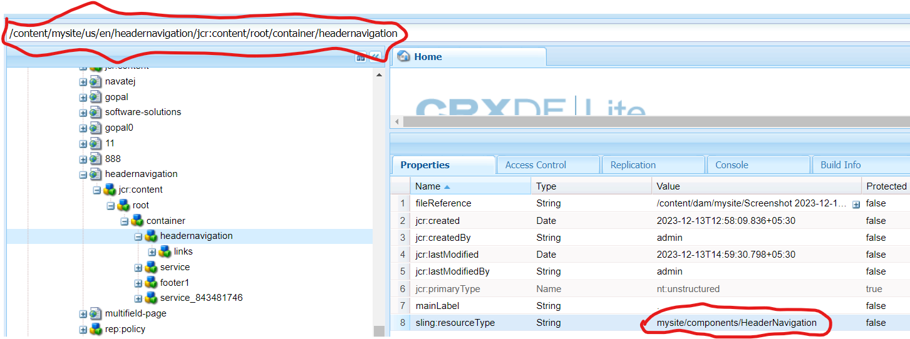

OUTPUT:

